***Content:***

***ESVP PRESIDENT CORNER 1***

***ECVP president CORNER 2***

***ESVP SECRETARY CORNER 3***

***ESVP-ECVP SCIENTIFIC COMMITTEE CORNER 3***

***The 2019 ESVP/ECVP Meeting Corner 3***

***Future meetings 5***

***Davis Thompson DVM Foundation Corner 5***

 **ESVP president corner**

*Wolfgang Baumgärtner*

___________________________________________

Dear Colleagues,

Surprise, surprise it is already June 2019. It seems it is just a few days ago that we met in Cluj-Napoca and now, we are again in the middle of the preparations for the next ESVP/ECVP meeting, jointly organized with our sister society and college specialized in Veterinary Clinical Pathology. Meetings like this will not only strengthen the relationship between different European societies working in similar and related fields but will also, especially in the present case, allow use to foster our own discipline by sharing diagnostic- and research-related experience, recent developments and future concepts.

The balancing act between providing outstanding, innovative teaching to undergraduate veterinary students and residents on one hand by including the enormous and permanently increasing knowledge, without losing an overarching approach referring to the basics in veterinary pathology and, on the other hand, triggering the interest in hypothesis driven research for the benefit of animals and the society, represents a permanent challenge. However, both goals need to be accomplished in order to fulfill the requirements of a university relevant training and education, sometimes it seems impossible to provide sufficient attention and expertise to both aims. Considering these challenges with respect to training in pathology and expected achievement in research, the up-coming meeting in Arnhem, on 25th-28th September this year, represents another milestone complementing the needs of young and established pathologists with respect to learning, improving and replenishing diagnostic skills, and becoming exposed the various *in vivo* and *in vitro* research topics and tools.

The focus of the up-coming meeting includes molecular research and effects of disease on wildlife conservation. The selected venue seems to be the perfect place for such a congress. Besides emphasizing zoo and wild life animal disease, the meeting will of course, also cover topics related to companion and farm animals. Moreover, both diagnostics and pathogenetic studies applying modern, innovative technologies will complement the wide-ranging topics of this meeting. The up-coming congress provides an outstanding collection of State-of-the-Art keynote lectures, interactive workshops, poster presentations, poster flashes and oral presentations fostering soft skills in data presentation and discussions in a scientific manner. Further topics include educational sessions about how to set up a research project and how to evaluate scientific publications to ensure a holistic in-service and advanced training. Furthermore, exchange and networking between anatomic and clinical pathologist will be another highly appreciated “add on” point of this meeting.

I am especially looking forward to the new pre-meeting day devoted to our residents. We really hope that this day will foster the professional development of our trainees and will provide them with another piece of information in the toolbox needed for a successful career. In other words, this may be the start of a new concept to further include our residents in our meeting by devoting a special day to their needs. Frankly, future themes and topics of such a day are still open for discussion and comments, and residents are especially encouraged to submit ideas and proposals.

In this respect this meeting provides a great platform to refresh your knowledge in neglected fields, keep up with emerging concepts and expand your professional expertise. Nowadays it is not possible to have an in-depth knowledge in all sub-specialties within the field of veterinary pathology. Therefore, it is important to have a strong network to obtain complementary support to ensure good and solid diagnostics, analysis and science. In order to accomplish these goals such a meeting is the best place to start, with this in mind enjoy this congress and make it to your own success story.

I am looking forward to meet you in Arnhem.

With best regards

W. Baumgärtner

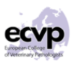 **ECVP President corner**

*Pierre Maliver*___________________________________________

Dear colleagues,

The next annual meeting of veterinary anatomical and clinical pathology (ECVP – ESVP – ECVCP - ESVCP; 25th - 28th September 2019) will take place in Arnhem, The Netherlands, and will be a great opportunity for veterinary anatomical and clinical pathologists to meet and exchange knowledge and experiences.

We would like to invite you to join us to meet like-minded people, become aware of new research developments in both of our fields and in realizing how closely intertwined they are. In this day and age when pathology becomes increasingly digitalized, the combination of anatomical pathology and clinical pathology data for diagnostic and experimental interpretations is becoming more and more evident and convincing.

As usual, representatives from the ECVP Council and our Committees will attend the meeting and will be pleased to discuss topics with any colleague interested in our activities.

Again, we will run a session dedicated for trainers and residents to present updates of the ECVP examination. The session will take place on Friday morning.

We look forward to seeing you at the meeting!

Sincerely,

Your ECVP Council

**ESVP Secretary Corner**

*Gail Leeming*

___________________________________________

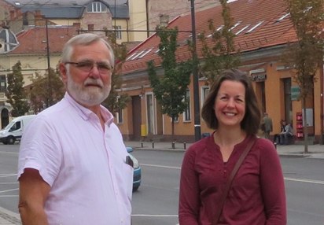The ESVP is pleased to announce that the Society is sponsoring five bursaries of €400 each for trainees who are attending the ECVP/ESVP Summer School in in Alfara del Patriarca, Valencia, Spain, from Monday 16th July to Friday 26th July 2019. All ECVP registered trainees who applied for the Summer School stipend were considered; priority was given to those applicants who are members of the ESVP, have no outstanding membership fees and have not previously been awarded a bursary, or did not receive a stipend from the ECVP for the summer school. We wish the summer school organizers and all the trainees attending a very successful and rewarding fortnight!



**ESVP-ECVP**

**Scientific committee corner**

___________________________________________

Dear colleagues and friends,

As you all know, the main task of the Joint Scientific Committee of the ESVP-ECVP is to work, together with the Local Organisers, to provide you with the most valuable and enjoyable programme for our Annual Meeting.

As this is your meeting, we will be pleased to build with all of you an interesting programme that best meets the expectations and interests of our trainees, young, and less young pathologists, working in the different fields of our discipline.

For this reason, over that the last few years we have asked for your opinion and comments, either by paper or electronic questionnaires, after the Annual Meeting. We have used your comments to improve our congresses. We would like to increase your input and participation in this continuing improvement process, and to enable you to feel even more involved in the scientific content of our Meeting. In the next few weeks, the SC will provide an online suggestion box on the ESVP website. Here you can provide valuable proposals for topics, speakers, type of sessions..... please free your imagination! This way, you can give your opinions and proposals at any time of the year, which we may then set to music in our future programmes!

We hope that this initiative will catch your interest and attention, for the benefit of our future meetings and of our whole community.

We wish you all a great ESVP-ECVP Meeting in Arnhem, The Netherlands, on 25 to 28th September 2019.

**The 2019 ESVP/ECVP Meeting Corner**

___________________________________________

The 2019 ESVP/ECVP congress will be a joint congress with the Veterinary Clinical Pathology Society and Council (ESVCP/ECVCP) and will take place in the Netherlands from 25-28th September. This is a few weeks later than the regular time slot so make sure to highlight it in your agenda!

The annual meeting in Arnhem will start this year with a residents/CE day on Wednesday 25 September 2019. The aim of this day is to present information that is valuable for residents, PhD students or early career researchers. PathoVet (<http://www.pathovet.ch/>) kindly offered to sponsor the registration fees of 20 trainees (residents and/or PhD students) participating in this day. Eligible candidates are asked to submit a short (max 100 words) motivation of their participation to s.hoogland@uu.nl. Deadline is 31 July 2019.

This joint meeting will bring presentations of interest for both communities as well as parallel sessions on topics of specific interest to our “own” field. It will bring ample opportunity to meet with members of both specialties in a very special venue.

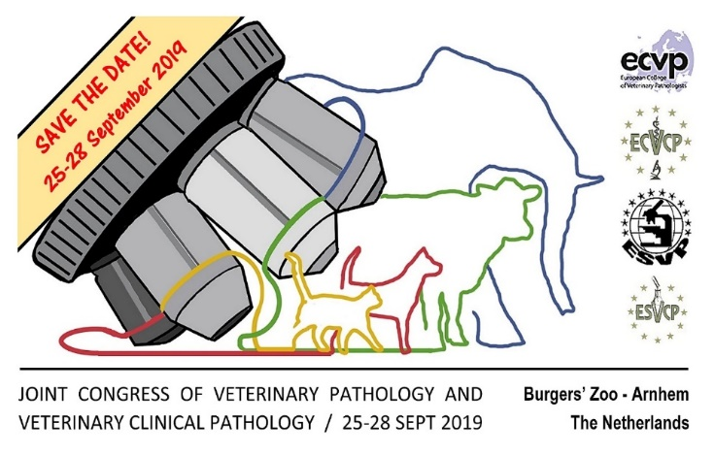The program will be balanced between the many areas of interest that make up the field of (clinical) pathology. The Thursday program will focus on farm animal topics and tumour classification, with a keynote lecture by Prof. Cuppen, biomedical geneticist and director of the Center of Molecular Medicine of Utrecht Medical Centre.

Another joint item on the program will be on the role of clinical and anatomical pathology in hematopoietic tumours by Leslie Sharkey and Nick Robinson, clinical pathologist and anatomical pathologist, respectively. A workshop on this item is also included in the program.

On the topic of farm animals we are striving to make sure that the emerging diseases, as well as the classical diseases, are met with a mix of workshops and lectures. The role of the pathologist in surveillance and monitoring of diseases will also be addressed.

The Friday’s main subject will be directly correlated to the venue of the meeting. We are very proud to welcome the three editors from the very recently published book: Pathology of WildLlife and Zoo Animals to our congress. Judy St. Leger, Karin Terio and Denise McAloose will provide us with a unique insight into diagnostics and its challenges in all types of wildlife. Dr. Marja Kik, veterinary pathologist at Utrecht University and specialist in reptiles and amphibians, will provide a workshop with unique cytologic and histologic material from the different zoos in the Netherlands, a true “behind the scenes” tour of the Zoo.

The venue that so neatly fits this field of interest is the congress hall of Royal Burgers’ Zoo in Arnhem. This Safari Meeting Centre is located in the heart of the Zoo, with a view of an indoor jungle on one side and giraffes and wildebeests on the other. More information on Zoo and Meeting Centre can be found at their website [www.burgerszoo.com](http://www.burgerszoo.com). Royal Burgers’ Zoo is famous for its biotopic displays and the work that Frans De Waal and Prof. Dr. Van Hooff did on behavioral studies in chimpanzees.

The city of Arnhem is located centrally in the Netherlands, with good train connections to international airports at Schiphol, Amsterdam and Frankfurt (1 hour and 1 hour 45 minutes respectively), as well as Eindhoven and Weeze (Germany) with many budget carriers flying there. Shuttle buses will be provided from the different hotels in the area to the Zoo, and Arnhem has a very good trolley-bus network if you should wish to travel on your own. Also, the access by your own car or perhaps even bicycle is also very good.

The Saturday afternoon will bring an extra program for those interested in educating residents. Professor Stephen May will share his insights and the latest scientific insights in this area.

All of the above leaves plenty of opportunities for poster tours, oral communications sessions, interactive slide sessions and a lovely congress dinner.

Arnhem has more to offer than a very beautiful Zoo. Close to the venue is the location of the Netherlands Open Air Museum which houses all those typical buildings that the Netherlands are famous for. The Park De Hoge Veluwe shows another side of nature in the Netherlands: woods and heather, and contains the famous van Gogh collection of the Kröller-Müller Museum. The city of Arnhem is comparatively small, but with a vibrant student life and a fine cultural agenda it is very worthwhile.

All information will be regularly updated and available soon on the congress website: [www.vetpathvetclinpath2019.sites.uu.nl](http://www.vetpathvetclinpath2019.sites.uu.nl)

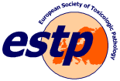**2020 Cutting Edge Pathology Meeting – Torino (Italy) – 26-29 August, 2020**

_________________________________________

The next Cutting Edge Pathology meeting, jointly organized by ESVP, ECVP and ESTP, will take place in Torino – Italy, on 26-29th August 2020.

The joint meeting program will include several interesting topics both for pathologists and toxicologists with a wide range of presentations, posters, lectures and seminars of interest for both communities and it will offer the opportunity to meet specialists of both disciplines in an international venue.

Scientists from Europe and beyond will present their scientific contribution in joint sessions and will discuss traditional and innovative results in all areas of pathology and toxicopathology.

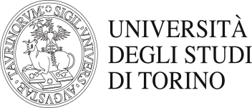Attending the CEP 2020 Meeting in Torino will also give you the opportunity to discover a pleasant and historical town in the north of Italy, and with a 250 years history, one of the oldest Veterinary Schools in the world.

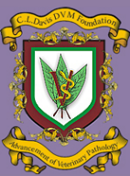

**Davis Thompson DVM Foundation Corner**_________________________________________

The Davis Thompson DVM Foundation would like to invite you to the European Division Symposium to be held in Arnhem, the Netherlands on 24th and 25th September 2019, just before the ECVP/ESVP Annual Meeting. Our three illustrious speakers, Drs St Leger, Terio and McAloose, have just recently published their new, well-received textbook entitled “Pathology of Wildlife and Zoo Animals”. Lectures will include wildlife necropsies, mass mortalities, the cytology and histology of wildlife cases and the diseases of pinnipeds, whales, dolphins, reptiles, amphibians and carnivores. In addition we will have an interactive session each day, in the style of a gross/histology quiz, with audience participation.

The early bird registration is €390 (until 30/06/19). Please register and pay by credit card at <https://www.eventbrite.co.uk/e/davis-thompson-dvm-foundation-european-symposium-zoo-pathology-tickets-50901990223?utm_term=eventname_text>

Newsletter editors: *Sanja Aleksic-Kovacevic* and *Pompei Bolfa*

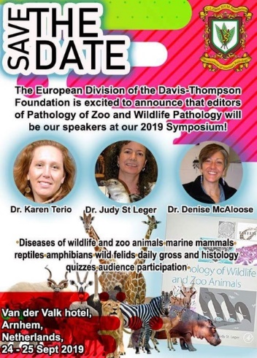This year the European Division will be offering five bursaries to delegates who are residents in full time veterinary pathology training or registered for a PhD. The award includes 450 euros for travel and accommodation and free registration. Details can be found in the brochure.

It would be great if you could join us in the Netherlands in September this year!