ESVP President’s corner
Jérôme Abadie ___________________________________________

Dear ESVP Members, dear colleagues, dear friends,
Content:
ESVP PRESIDENT’S CORNER 1
ESVP SECRETARY’S CORNER 1
ECVP-ESVP- ANNUAL METING 2022 2
ESVP TREASURER’S CORNER 2
UPCOMING WEBINARS 3
THE ROLE OF THE ESVP LIASON FOR LOCS 3
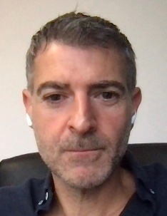
This is a great honour and pleasure to write you few words as the new President of our Society.
I would like first to deeply acknowledge Wolfgang for his 6 years commitment as President and for the way he manages the team of Board members. I and my friends in the Board, including Wolfgang as Past President, are deeply motivated to continue our work for our community of pathologists. We aim to be useful to the promotion of our beautiful discipline, in conjunction with the ECVP council and members and with the participation and agreements of all of you.
The 2021 year that will soon end was still a complicated period for our personal and professional life in Europe. As a consequence, we have organised, for the first time, our Cutting Edge meeting together with the ECVP and our sister society ESTP, as a digital conference this year. It was a leap into the unknown.

Thanks to all the involved people (the « local » organiser, the professional congress organisation, the sponsors, the boards of the ESVP, ESTP and ECVP and especially the Scientific Committee), and mainly thanks to you, this event was successful with a large audience to the various sessions and very positive feedbacks from you. This was for us a great achievement in this complicated period.
However, even if the digital communication tools and platforms have strongly improved and become more and more used and familiar to us, a digital congress could never replace a face-to-face event, particularly in terms of sociability and human interactions, that are so important in the current period.
Thus, we are all working for the organisation of our next Congress, in Athens 2022, with the very efficient and motivated local organiser and professional congress organisation teams, as a total presential event.
All Board members and I are looking forward to welcome you at our next annual meeting, from the 6 to 10th September 2022 in Athens, and see and talk to you for real.
Stay healthy and take care.
Yours,
Jérôme

ESVP Secretary’s Corner
Gail Leeming
___________________________________________
It has, again, been a strange period in which some things are getting back to normal, but many are not yet. Our virtual Cutting Edge congress typifies this, but there are also silver linings to the pandemic cloud, in that new ideas and ways of doing things have been generated, which in some cases is an improvement and may well be kept for the future. The digital posters were a great example of this. Being able read the posters carefully (without looking over someone else’s shoulder!) and hear from the author about their work was great. Hopefully 2022 will bring the best bits of the new innovations and also actually getting to see each other and properly catch up with colleagues again. Meeting people from so many different countries in our (relatively) small profession is one of the great delights of our work and for me, the ESVP has played a big part in this. If you would like to meet more people and get more involved, there will be a vacancy on the board for a new Honorary Secretary in 2022, so please get in touch if this is you!

ECVP-ESVP- annual meeting
___________________________________________
Twenty years after Greece first hosted the ESVP-ECVP meeting, we are looking forward to welcoming you again, to the 2022 ESVP-ECVP Congress be held in Athens on 6th - 10th September. We sincerely hope that this time we will have the opportunity to hold our meeting face to face. With the assistance of the Scientific Committee, we intend to organise a conference of great scientific value, featuring various aspects of Veterinary Pathology.
After a prolonged period of social distancing and travel restrictions that have influenced many aspects of our professional life, we are looking forward to meeting in person and creating opportunities to interact with international colleagues, creating and renewing relationships and collaborations.
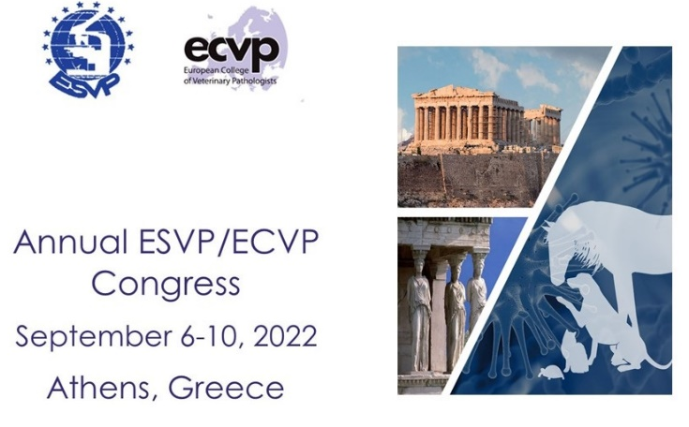
The Local Organizing Committee is comprised of academic staff from the two Veterinary Schools of Greece, one in Thessaloniki and the other in Karditsa. All colleagues from the committee will be happy to assist you in organising your participation and provide you with any information you may need.
Athens is a city with long history and a nice summer climate in the beginning of September. Access from all European countries is easy.
On behalf of the Local Organising Committee, we invite you to visit Athens for a constructive congress.

Dimitra Psalla
Nikos Papaioannou

ESVP Treasurer’s corner
Reinie Dijkman
___________________________________________
Dear members,
If we could name one beneficial thing coming from the pandemic situation, it is the increased virtual nearness that we experience. Though in no way replacing the meetings in person and the coming together for courses and congresses (and this is also financially speaking) it is a great addition for the times in between that were usually without much contact. The contact that a treasurer has with members of any Society is usually about money of course, but because most of the moneyflow is coming in (when we start spending I will let you know!) I thought to take a quick look around where it’s coming from.
Costa Rica is a place that pops to mind because, ladies and gentlemen, it is not easy to transfer money from there to the ESVP. The mysterious ways of digital money……
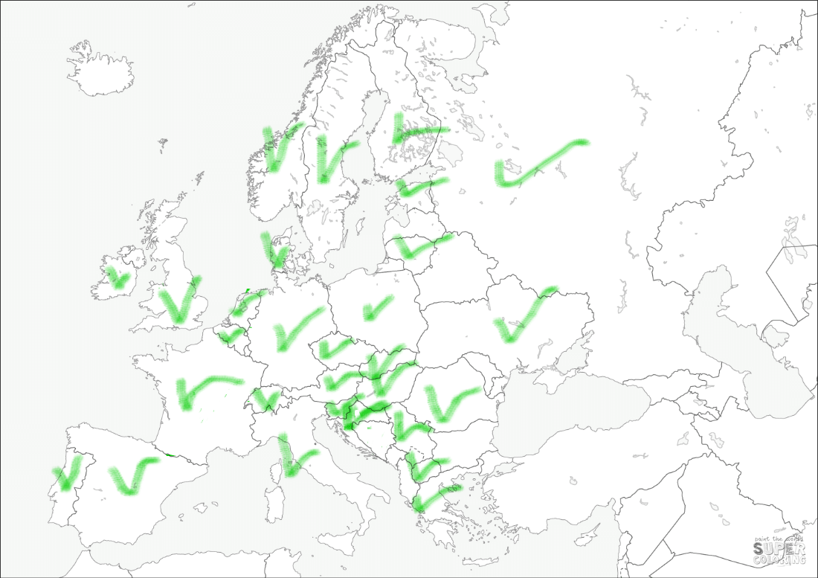
Most countries have it easier. I looked up where our members are and all your colleagues are distributed over 35 different countries! All the marked countries on the European continent and a few even further away: Costa Rica was mentioned, but also the USA, Argentina, Uganda and Australia are in the list. Sometimes it’s fun to “follow the money” and feel connected with so many members in so many places.
I hope to see you all soon, be it in person or in some coded form!

Upcoming webinars
___________________________________________
In November 2021, the monthly lymphoma meeting organized by the anatomic pathology department of IDEXX UK resumed. Lymphoma meeting is hold on monthly based. This is a 30 minute meeting where interesting lymphoma cases from the routine diagnostic caseload are presented and discussed. Due to the informal nature of this meeting, all the ESVP members are invited to participate at the discussion, to raise questions or queries, to provide opinions based in their experience on the topic: the goal of these meetings is to have the opportunity to learn together and share knowledge. We encourage you to give any suggestion or feedback about the meeting, and about future topics you would be interested to deal with, completing the survey at the link below, or writing us an email. We need your support and help to make the best for you!
https://www.surveymonkey.com/r/KNPPJF3

The role of the ESVP liason for LOCs
Polona Juntes ___________________________________________
One of the Council members of the ESVP Board acts as a contact person, liasion, for the Local Organising Committees (LOCs) of the ESVP Annual Meetings, which are organised annually together with the European College of Veterinary Pathologists (ECVP), and every third year as Cutting Edge Pathology together with the European Sociery of Toxicological Pathology (ESTP). The role of a liasion is not defined in the ESVP Constitution, but it has been formed to provide a continuous follow-up of the activities of LOC in the current year, those that need to be completed for the previous year's annual meeting, and those that need to be completed by the LOCs of at least two to three future annual meetings. Most contact between LOCs and the ESVP Board is usually between the ESVP President, Secretary, Treasurer, and Scientific Committee, but the liasion needs to get an overview of whether the organisation is following the protocols defined in the Standard Operational Procedure for LOC (SOP for LOCs). Last year was an exception as the 2020 annual meeting was cancelled due to the epidemic of COVID-19 and 2021 was organised online, so fewer activities were required for the liaison. However, activities for the 2022 meeting in Athens and 2023 in Lisbon are well underway, and preparations for the 2024 meeting in Madrid have begun.
To outline some of the expected activities of the LOC detailed in the ESVP/ECVP document »Local Organising Committee (LOC): SOP for ESVP/ECVP Annual Congresses«, which is available to members and potential organisers of annual meetings on the ESVP homepage in the Members Only section.

Newsletter editors: Sanja Aleksic-Kovacevic and Pompei Bolfa

Once a potential organiser has expressed interest in hosting the annual meeting and the initial proposal has been accepted by the ESVP Board, LOC must prepare a written proposal for a venue at least three years prior to the meeting, and liaison activities for LOC will begin at the same time. LOC must follow the instructions listed for LOCs at SOP, and the liaison must follow the implementation. To accomplish this, LOC is expected to provide feedback on its activities upon request, typically three, two, and one years prior to the meeting, in the year of the meeting and in the year after the meeting, when the organisational cycle is complete. To receive feedback, the liaison sends a list of expected activities to the LOCs, and the LOCs confirm what has already been done. Most activities occur in the year before and the year of the annual meeting, and if LOC follows the rules of SOP, the liason has the least amount of work. If LOC does not follow the rules of SOP and does not do what is expected in a given period of time, this is reported to the Board and further activities follow to resolve the issues.

