ESVP President’s corner
Content:
ESVP PRESIDENT’S CORNER 1
ESVP SECRETARY’S CORNER 1
ECVP PRESIDENT’S CORNER 2
ECVP-ESVP- ANNUAL METING 2022 3
ESVP TREASURER’S CORNER 3
UDATES ON WEBINARS 4
ESVP MEMBER CHAT 4
Future meetings - Lisbon 2023 4
Jérôme Abadie ___________________________________________

Dear Members of the Society, dear friends,
The two recent years and the current period is a difficult moment for our continent Europe.
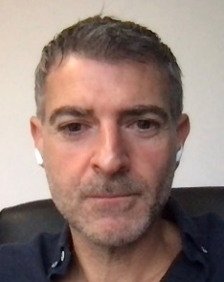
We are facing undoubtedly moments when we have to stand together as a community, to defend our model of life and fight for the values of freedom and democracy.
In Greek mythology, Europa was a Phoenician princess of Argive Greek origin of which Zeus was enamoured. In this so difficult and deeply sad period for our continent, time is coming to go back to the roots of Europe and to this princess. There is no better place at this moment for renewing the links between us, members of the Veterinary Pathology community, than Greece, the cradle of democracy.

Thus, Athens will welcome us from the 7 to 10 September 2022, as a total presential congress. I would like to deeply thank the local organising committee, the professional congress organisation, the sponsors, the board of the ESVP and ECVP council and especially the Scientific Committee, for their commitment and works on this event. The scientific program is of great value and the venue of our annual meeting in Athens will be the place to be early September.
After the Covid period, that has deeply impacted our professional and personal life, the war in Ukraine is nowadays a terrible event. In solidarity with the Ukrainian community of veterinary pathologists, we would like to propose a small action of recomfort by welcoming for free our Ukrainian colleagues that might have been forced to take refuge in neighbouring countries in Europe since the beginning of the war. If you or colleagues know personally or have welcome in your faculty/laboratory Ukrainian pathologists which would like to join our Society and attend our next congress in Athens, please fill free to contact me or any ESVP Board members.
We are looking forward to welcome them and you all at our next annual meeting in the wonderful city of Athens.
We hope many of you will be able to participate to this event, we all have expected for many months, in order to see and talk to each other, for real.
Sincerely, Jérôme Abadie

ESVP Secretary’s Corner
Gail Leeming
___________________________________________
I have had the pleasure of being the honorary secretary of the board of the ESVP for six years. My first meeting as secretary was in Bologna in 2016. During this time, I have had the chance to meet and work with many different lovely people and experience the hospitality of many colleagues. I have very much enjoyed these last six years, however my time as secretary is now coming to an end as constitutionally, I cannot stand again. Therefore, we are looking for a new secretary for the board. If you are interested or would like to know more, please email me at secretary@esvp.eu to find out more. I am willing to offer whatever help the incoming secretary would like during the handover period, and, as The University of Liverpool will be host the ECVP/ESVP Summer School in the not-too-distant future, I hope that I will be able to continue to work closely with many of the friends and acquaintances I have made.

ECVP President’s corner
Andrea Gröne ___________________________________________
Dear ESVP members,
With the following, I would like to give you a short update about activities of the European College of Veterinary Pathologists (ECVP) in the last 12 months.
After we were able to give the 2020 ECVP exam, just before the pandemic led to a general close-down of traffic, we were presented with the fact that the 2021 exam would be a major challenge. First, we moved the exam from February 2021 to June, in the hope that the situation may improve so that it could take place, as usual, in Ghent. However, due to travel restrictions this was not possible and in the end the exam was held in 9 different locations in three time zones with more than 50 people involved. General organization of the event in each location, secure shipping of the exam material, invigilation as required by EBVS, correction of the exam and ensuring communication between the sites was taken care of. This was a major effort for everyone involved and we are very grateful not only to the members of the Examination Committee, but also to the colleagues from the ECVP and diplomates from other Colleges hosting the event on site.
In fall 2021, we were following the pandemic situation very closely and decided that an exam in Ghent would be possible in February 2022 with specific adaptations: candidates and Examination Committee members had to wear masks all the time, the time for histology was extended and a break was introduced. The exam went well and resulted in 12 new diplomates (https://www.ecvpath.org/congratulations-to-the-ecvp-new-diplomates/).
Furthermore, the digitization process of the ECVP exam has begun with providing the section General Pathology on the platform ExamSoft. This will be extended to the section Veterinary Pathology in 2023.
We also evaluated the current exam structure and after discussing advantages and disadvantages of various modifications, the decision was made that a change at the moment is not useful.
Webinars for residents were organized during the pandemics and will continue, thanks to a dedicated task force. These will be open for ESVP members as well in the future.
The Summer School 2022 will take place in Zagreb, Croatia, from 11 to 22 July, and once more there will be bursaries covering attendance fee. The Education Committee has put together a very good program with excellent lecturers. Please see https://www.ecvpath.org/summerschool/.
And last but not least, we are looking forward to the Annual Congress in Athens and the opportunity to meet each other in person. See you then and stay well!

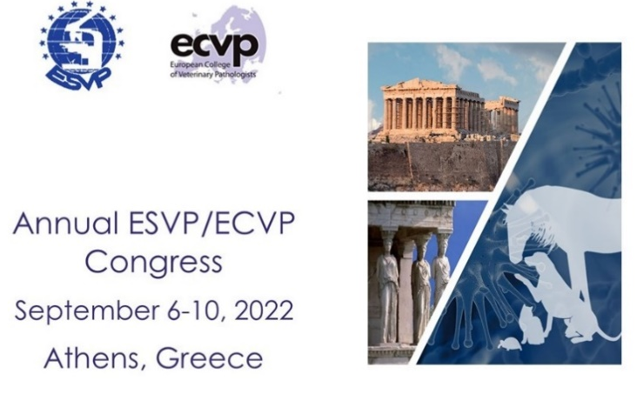
ECVP-ESVP - annual meeting
Dimitra Psalla
___________________________________________
Dear Colleagues and Friends,
On behalf of the Local Organising Committee, I am delighted to invite you to Athens, Greece for the Annual ESVP-ECVP Congress in 2022.
An exceptional scientific program has been developed, for both young and experienced delegates, all presented by distinguished speakers, and including sessions to promote networking between speakers and the audience.
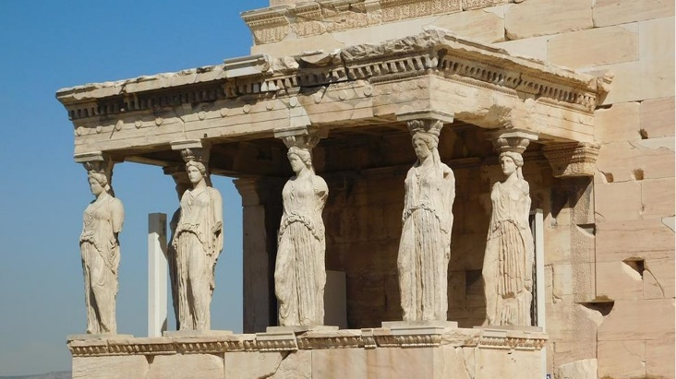
We are preparing an inspiring congress for 2022 in Athens, this magnificent Greek city. As a historic world capital and vibrant knowledge hub, the innate spirit of Plato’s Symposium still burns brightly in Athens today, making for spirited and fruitful international meetings and exciting events.
We are so happy to safely meet again in person, after prolonged pandemic-related restrictions, to enjoy gathering of our community. Counting on your support, enthusiasm, and active participation in this special event, we are looking forward to meeting you in September 2022.
On the Congress website (https://esvp-ecvp2022.frei.gr) you may find details about the important dates, scientific programme, the abstract submission form, information about accommodation and the city of Athens, as well as useful links for your visit.
Prof. Dr. Dimitra Psalla

ESVP Treasurer’s corner
Reinie Dijkman
___________________________________________
Dear members,
It looks like the next congress will be an on-site congress again and I am looking forward to meeting you all in Athens!
The ESVP has decided to celebrate this by giving out 4 bursaries for residents to attend the congress, including the residents day. So, if you are a junior member of ESVP and would like to attend in Athens please contact me via treasurer@esvp.eu before June 1st, and we will make a selection. We will let you know the results before the early bird fee expires of course! For details of the program, please check https://esvp-ecvp2022.frei.gr/.
Besides that, ESVP will be sponsoring bursaries of €400 each for trainees who are attending the ECVP/ESVP Summer School this year. ECVP registered trainees can apply for the Summer School stipend.
Applicants need to be a junior member of the ESVP and have no outstanding membership fees, and priority will be given to candidates that did not previously receive a bursary from either ESVP or ECVP. However, all applicants will be considered and are encouraged to apply.
I wish you all the best and hope to meet you in Athens in September,
Groeten,

Updates on webinars
Elena Riccardi
___________________________________________
In 2021, the ESVP started the project of providing continuing education activities to the associates. Every month, the associates have the chance to join the Lymphoma meetings organized by the Anatomic Pathology Department of IDEXX UK, will be resumed. This is a 30-minute meeting where interesting lymphoma cases from the routine diagnostic caseload are presented and discussed. This is an informal meeting, mainly addressed to pathologists already working in research or diagnostics, but helpful also for trainees. So far, the meeting has a good attendance, with an average of 50 participants.
The goal, for the future, is to increase the opportunity to provide education activities. In case you have similar events occurring in your institutions and you think it is possible to share it with the other associates, please do not hesitate to contact the ESVP.
In addition, please remember to check the ESVP website: new job opportunities are published regularly. In case your institutions have job positions you’d like to advertise to our web site, do not hesitate to contact us!

ESVP Member Chat
Ivana Vucicevic ___________________________________________
There is a new option on the ESVP webpage – Member Chat (https://www.esvp.eu/esvp/member-chat). It allows logged in site members to chat with each other. There is a list of members currently online. Members can enter different chat rooms and read and send messages that will be visible to others. We look forward to having a conversation on different topics.

Future meetings - Lisbon 2023
Pedro Faísca DVM, DEA, PhD Co-Chair of the LOC
___________________________________________
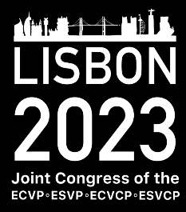
The European Society of Veterinary Pathology, the European College of Veterinary Pathologists, the European College of Veterinary Clinical Pathology and the European Society of Veterinary Clinical Pathology are organizing their joint Conference ECVP/ESVP/ECVCP/ESVCP.
This international conference will be held from 31st August to 2nd September 2023 at the Lisbon Meeting Center, in the beautiful, historical quarter of Belem, Lisbon, Portugal. https://lisbonvenues.pt/en/lisbon-congress-center/.
A 1000 m² conference floor will gather around 500 professionals from these areas from all over Europe and other parts of the world, for 2 and a half days.
It will be a full week dedicated to veterinary pathology with two satellite meetings and a Residence Day prior to the conference. The two satellite meetings will be
Newsletter editors: Sanja Aleksic-Kovacevic and Pompei Bolfa

one from the Davis-Thompson Foundation and the other from the International Society of Veterinary Dermatopathology.

